Y Plas
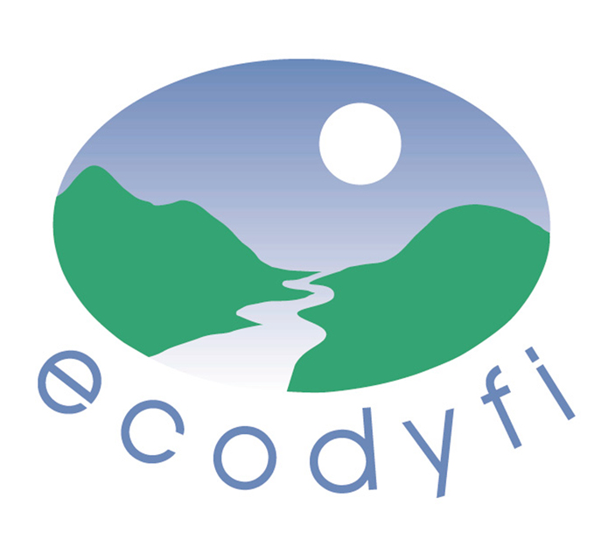

Machynlleth

SY20 8ER
01654 703965
www.ecodyfi.wales

Press Release
26 May 2020

Community wind turbines fund Covid19 support

The Dyfi Community Energy Fund - which offers grants to local groups - has decided to donate this year’s grant to five local voluntary groups responding to the COVID19 crisis.

The Fund receives its income from Bro Dyfi Community Renewables - the co-operative that owns two wind turbines above Pantperthog in the Dulas Valley. The Fund is managed by a committee consisting of Bro Dyfi Community Renewables, ecodyfi and Glantwymyn and Corris Community Councils. Ecodyfi provides the administration.

The grant is usually offered for activities that reduce carbon emissions, fight climate change or improve resilience, but the eligibility criteria were widened on this occasion. The Committee decided to offer grants totally nearly £5,000 to voluntary groups helping residents of the area struggling to cope with the current pandemic.

Seven applications were received for grants with a maximum of £1,000 and the Committee awarded grants to the groups who could best:
- Support individuals and households most in need, whether financially, practically, socially, with their health and wellbeing, or otherwise;
- Build solidarity, community and resilience (of individuals, groups of people or the area).

And the successful applicants are:
- Dyfi PPE http://ppe.machynlleth.wales – a network of individuals, small businesses and educational venues working collectively, demonstrating and building community resilience. The grant goes towards the costs of materials.
- CAMAD http://www.camad.org.uk/ - mainly to assist with the costs of volunteers collecting prescriptions and shopping for vulnerable people.
- Heart Mind Body Support https://www.coedlleol.org.uk/heart-mind-body-support/- @HMBsupport - a group that tackles social isolation and loneliness by reaching out to those people who currently lack contact and community connections, through telephone support and online wellbeing activities.
- Ysgol Bro Hyddgen https://brohyddgen.cymru/ – to buy seven Chromebooks for pupils in the Glantwymyn, Carno and Llanbrynmair areas who cannot access a computer at home to do their school work. The school will pay for another sixteen Chromebooks from the school budget.
- Food Justice for All @braichgoch - a group that provides free food to those who need it most (though donations are welcome) every Friday night out of the Braich Goch in Corris. The grant will contribute towards paper takeaway boxes, locally sourced ingredients, cooking utensils, fuel for volunteers to distribute the food and gas for cooking.

Rod Edwards, Chair of Bro Dyfi Community Renewables said, “Bro Dyfi Community Renewables is pleased to make these funding awards to other community groups acting for the social and health needs of residents in our mid Wales area during these challenging times. The Community Energy Fund, benefitting through proceeds from our two turbines above the Dulas valley, is awarded to several recipients not just to acknowledge their great deeds but hopefully to further strengthen community services in the area.”
ENDS
Further information:
Andy Rowland, ecodyfi Manager: 01654 702630

Notes to editors:

Ecodyfi operates primarily in the Dyfi Valley, but pursues opportunities outside the area if they are in line with the company's objectives and benefit local people. Our vision is for the Dyfi Valley to be a thriving, healthy, caring, close-knit, bilingual and outgoing community, increasingly notable for sustainable living.

During this pandemic ecodyfi has been providing online information on activities and support available in the Dyfi Biosphere area through its website https://www.ecodyfi.wales/.

Bro Dyfi Community Renewables is a community-led, community-owned wind turbine project in the Dyfi Valley. Through its 75kW and 500kW wind turbines the co-operative produces electricity equivalent to the demand of about 1,000 households in the area of Machynlleth. https://bdcr.org.uk/

Datganiad i'r wasg
26 Mai 2020

Tyrbinau gwynt cymunedol yn ariannu cefnogaeth Covid19

Mae Cronfa Ynni Cymunedol Dyfi - sy’n cynnig grantiau i grwpiau lleol - wedi penderfynu rhoi grant eleni i bum grŵp gwirfoddol lleol sy’n ymateb i argyfwng COVID19.

Mae'r Gronfa yn derbyn ei hincwm gan Bro Dyfi Community Renewables - y cwmni cydweithredol sy'n berchen ar ddau dyrbin gwynt uwchben Pantperthog yn Nyffryn Dulas. Rheolir y Gronfa gan bwyllgor sy'n cynnwys Ynni Adnewyddadwy Cymunedol Bro Ddyfi, Cynghorau Cymuned Glantwymyn a Corris ac ecodyfi. Ecodyfi sy'n darparu'r weinyddiaeth.

Cynigir y grant fel arfer ar gyfer gweithgareddau sy'n lleihau allyriadau carbon, yn ymladd yn erbyn newid yn yr hinsawdd neu'n gwella gwytnwch, ond ehangwyd y meini prawf cymhwysedd y tro hwn. Penderfynodd y Pwyllgor gynnig grantiau o bron i £5,000 i grwpiau gwirfoddol oedd am helpu trigolion yr ardal sy'n ei chael hi'n anodd ymdopi â'r pandemig presennol.

Derbyniwyd saith cais am grantiau gydag uchafswm o £1,000 a dyfarnodd y Pwyllgor y grantiau i'r grwpiau a allai orau:
  - Gefnogi unigolion ac aelwydydd sydd â'r angen mwyaf, boed yn ariannol, yn ymarferol, yn gymdeithasol, gyda'u hiechyd a'u lles, neu fel arall;
  - Adeiladu undod, cymuned a gwytnwch (unigolion, grwpiau o bobl neu'r ardal).
A'r ymgeiswyr llwyddiannus yw:
  - Dyfi PPE http://ppe.machynlleth.wales- rhwydwaith o unigolion, busnesau bach a lleoliadau addysgol yn gweithio ar y cyd, yn arddangos ac yn adeiladu gwytnwch cymunedol. Mae'r grant yn mynd tuag at gostau deunyddiau.
  - CAMAD http://www.camad.org.uk/ - yn bennaf i gynorthwyo gyda chostau gwirfoddolwyr yn casglu presgripsiynau ac yn siopa i bobl agored i niwed.
  - Heart Mind Body Support https://www.coedlleol.org.uk/heart-mind-body-support/- @HMBsupport - grŵp sy'n mynd i'r afael ag arwahanrwydd cymdeithasol ac unigrwydd trwy estyn allan at y bobl hynny sydd ar hyn o bryd heb gysylltiadau cyswllt a chymunedol, trwy gymorth ffôn a gweithgareddau lles ar-lein.
  - Ysgol Bro Hyddgen https://brohyddgen.cymru/ - i brynu saith Llyfr Chrome i ddisgyblion yn ardaloedd Glantwymyn, Carno a Llanbrynmair nad ydyn nhw'n gallu cael mynediad I gyfrifiadur gartref i wneud eu gwaith ysgol. Bydd yr ysgol yn talu am un ar bymtheg arall o Lyfrau Chrome o gyllideb yr ysgol.
  - Food Justice for All @braichgoch - grŵp sy'n darparu bwyd am ddim i'r rhai sydd ei angen fwyaf (er bod croeso i roddion) bob nos Wener allan o'r Braich Goch yng Nghorris. Bydd y grant yn cyfrannu at flychau cludfwyd papur, cynhwysion o ffynonellau lleol, offer coginio, tanwydd i wirfoddolwyr ddosbarthu'r bwyd a'r nwy i goginio.
Dywedodd Rod Edwards, Cadeirydd Adnewyddadwy Cymunedol Bro Dyfi,
“Mae Bro Dyfi Community Renewables yn falch o roi’r gwobrau cyllido hyn i grwpiau cymunedol eraill sy'n gweithredu ar gyfer anghenion cymdeithasol ac iechyd preswylwyr yn ein hardal yng nghanol Cymru yn ystod yr amseroedd heriol hyn. Dyfernir y Gronfa Ynni Cymunedol, sy'n elwa o'r elw o'n dau dyrbin uwchben Dyffryn Dulas, i sawl derbynnydd nid yn unig i gydnabod eu gweithredoedd gwych ond gobeithio cryfhau gwasanaethau cymunedol ymhellach yn yr ardal. "

DIWEDD

Gwybodaeth bellach:
Andy Rowland, Rheolwr ecodyfi: 01654 702630

Nodiadau i olygyddion:
Mae ecodyfi yn gweithredu yn bennaf yn Nyffryn Dyfi, ond mae'n mynd ar drywydd cyfleoedd y tu allan i'r ardal os ydyn nhw'n unol ag amcanion y cwmni ac o fudd i bobl leol. Ein gweledigaeth yw i Ddyffryn Dyfi fod yn gymuned ffyniannus, iach, ofalgar, glos, dwyieithog ac allblyg, yn fwyfwy nodedig am fyw'n gynaliadwy.
Yn ystod y pandemig hwn mae ecodyfi wedi bod yn darparu gwybodaeth ar-lein am weithgareddau a chefnogaeth sydd ar gael yn ardal Biosffer Dyfi trwy ei wefan https://www.ecodyfi.wales/ .

Mae Bro Dyfi Community Renewables yn brosiect tyrbin gwynt dan berchnogaeth gymunedol yn Nyffryn Dyfi. Trwy ei dyrbinau gwynt 75kW a 500kW, mae'r fenter gydweithredol yn cynhyrchu trydan sy'n cyfateb i alw tua 1,000 o aelwydydd yn ardal Machynlleth. https://bdcr.org.uk/

